Billing Export - AWS
AWS supports exporting Cost and Usage Report (aka: CUR 2.0) as shown below. You can use Data Exports to export CUR, but it can only support exporting the billing report of current month. If you wanna analyze the billing report of previous month. You need consider the other way.

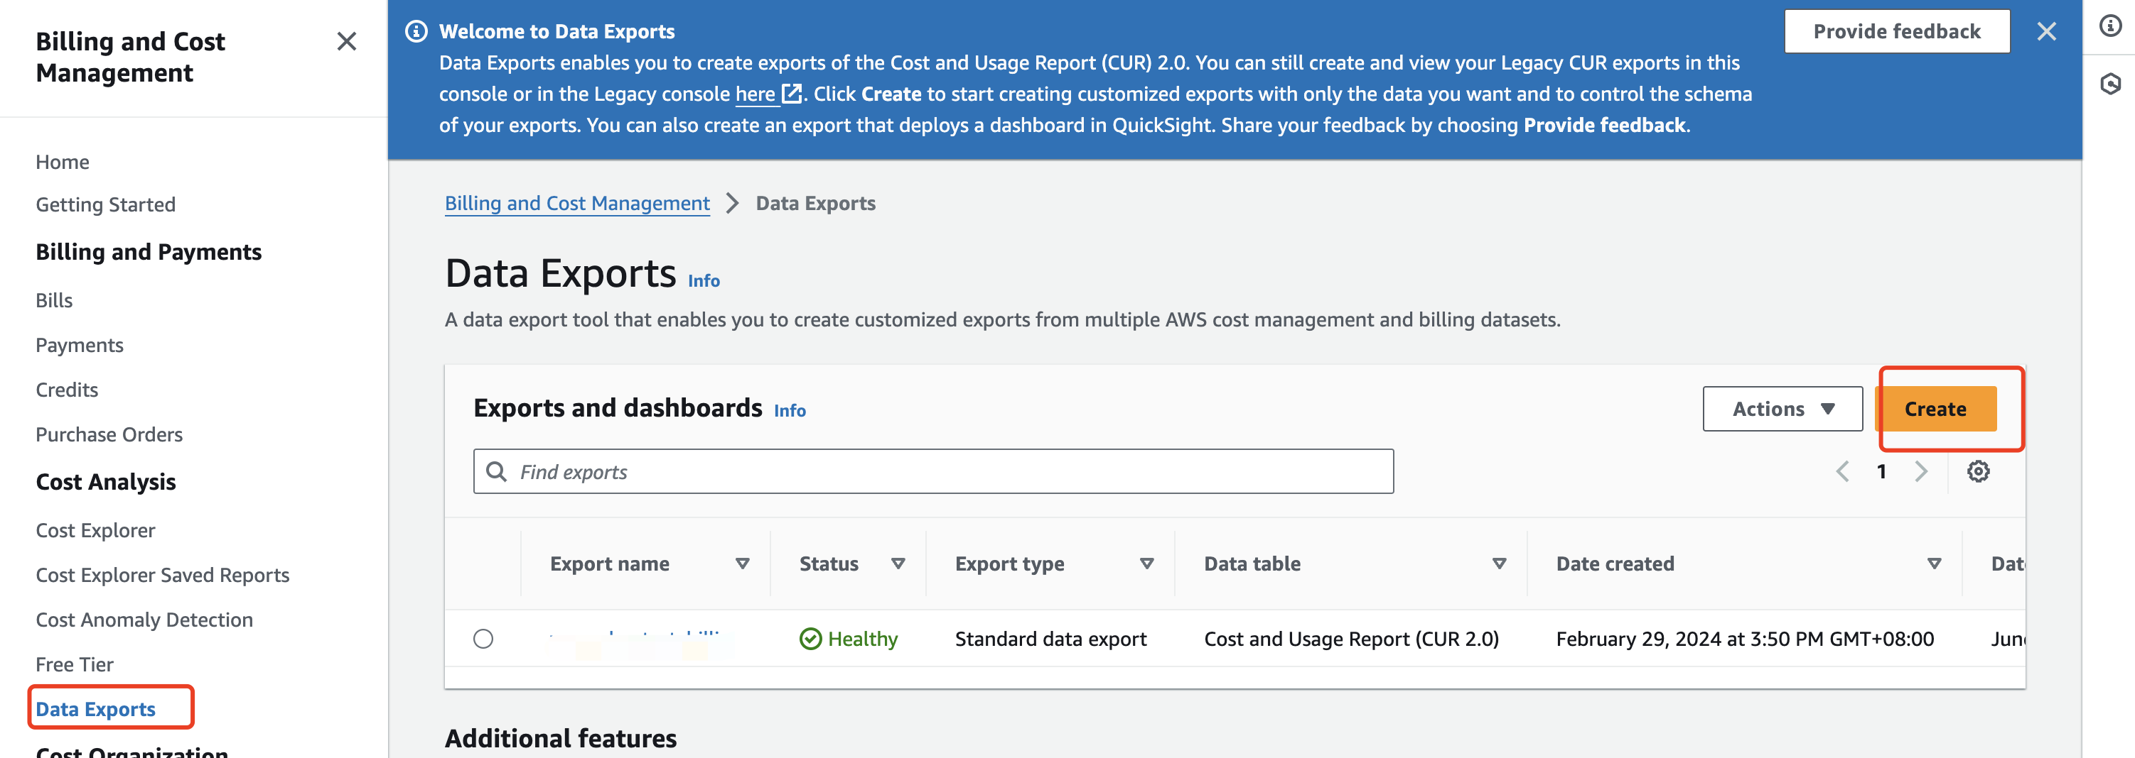

- If customer has AWS TAM support, they can ask TAM team to help export the billing report of specified month.
- If customer has no AWS TAM support, they can ask AWS Service Team to help export the billing report of specified month.

Key Points

Exporting File Format
Customer need provide the billing report with CSV file format .

Exporting Columns
The CUR 2.0 has 114 columns. We recommend to export specified fields as shown below:
product_servicecode
product_usagetype
bill_billing_period_start_date
bill_billing_period_end_date
line_item_usage_account_id
line_item_line_item_description
line_item_usage_amount
line_item_unblended_cost
line_item_line_item_type
product_location
pricing_rate_code
product_sku
line_item_unblended_rate
pricing_unit
product_operation

Exporting Steps
- Step1-Create exporting task: Go into Billing and Cost Management, and navigate to "Data Exports", and click "Create" button to create a new exporting task.
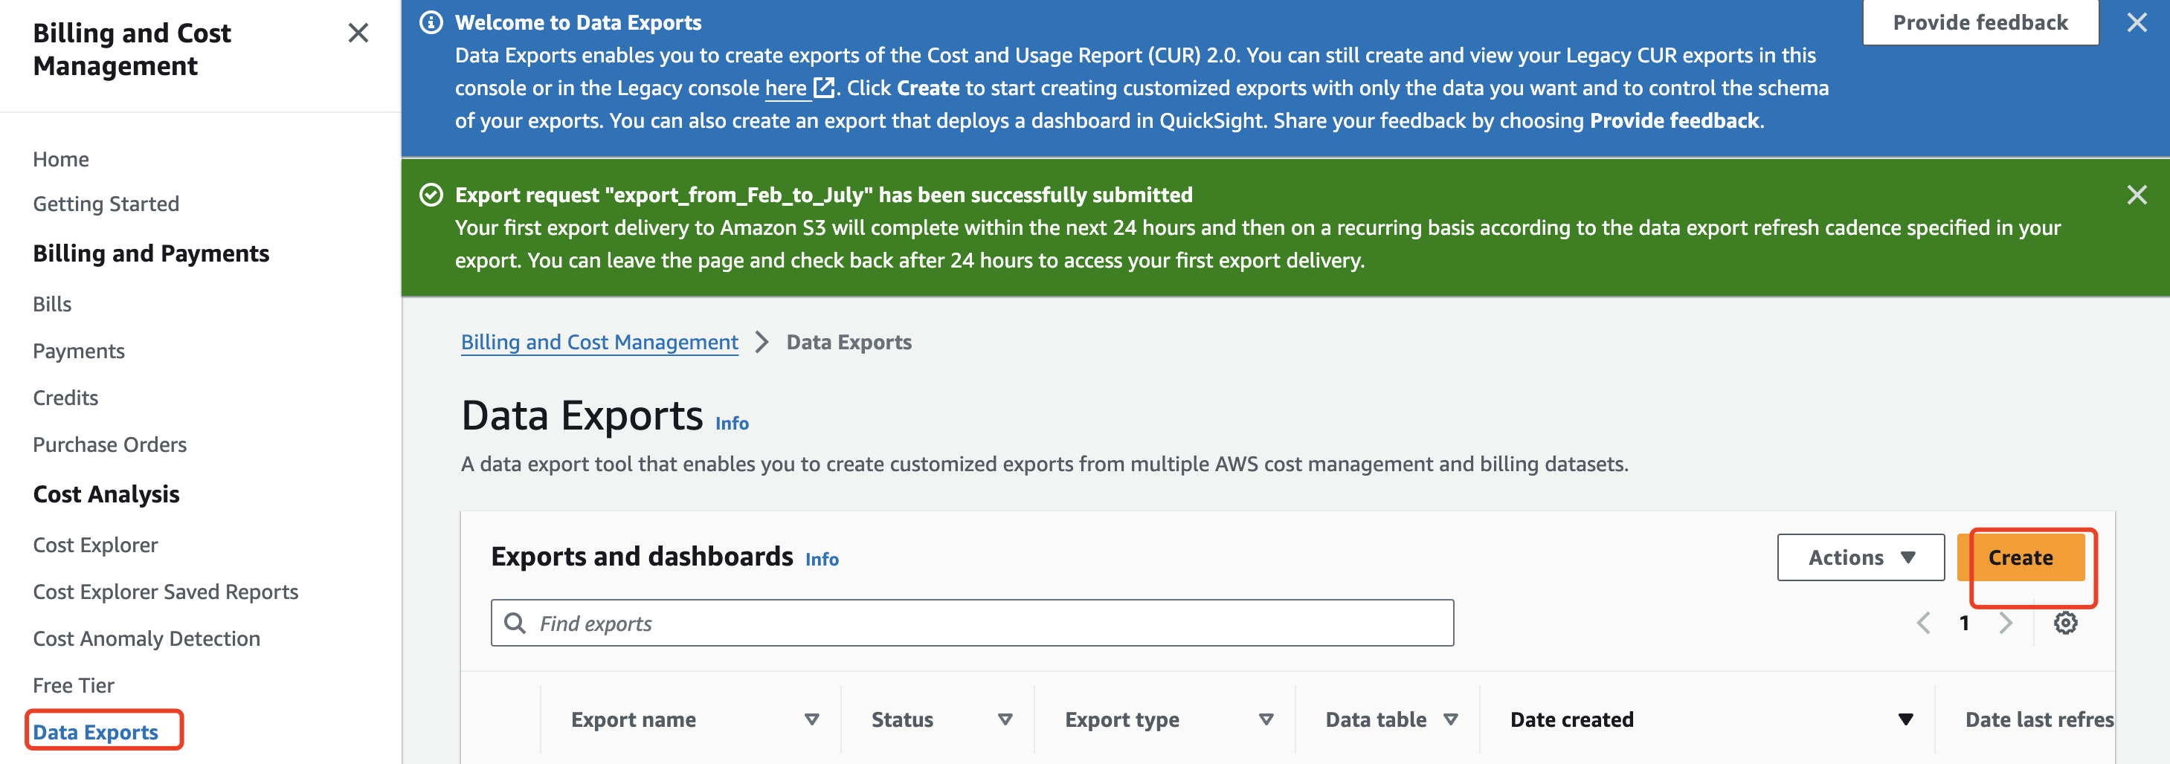
- Step2-Configure the exporting options:
  - Export type: Choose the "Standard data export"
  - Export name: Input the target Export name.
  - Data table content settings: Choose "CUR 2.0"
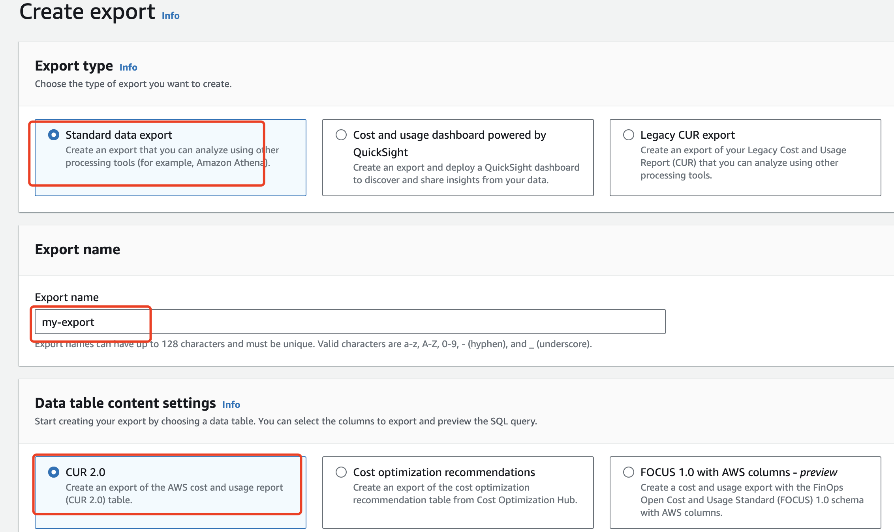
- Step3- Data table configurations:
  - Additional export content: Check the "Include resource IDs"
  - Time granularity: Choose the "Monthly".
  - Comumn selection: Default is 114, if customer wanna export specified columns, please refer to the required columns in Preparation section.
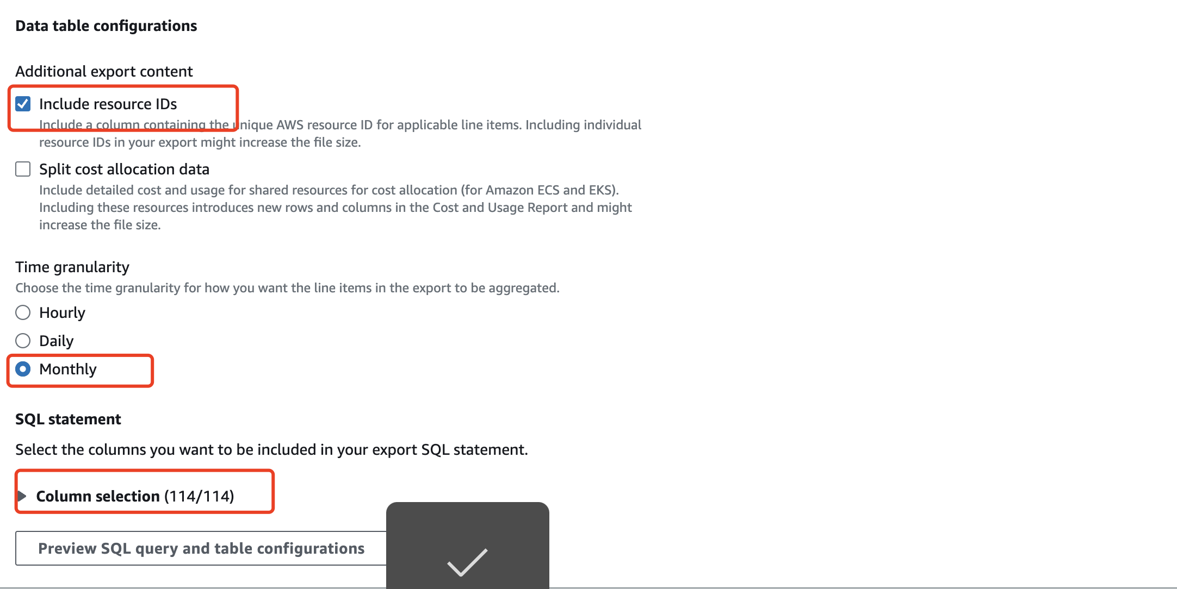

- Step4-Data export delivery options configuration:
  - Compression type and file format: Choose "gzip-text/csv".
  - File versioning: Choose "Overwrite existing data export file"
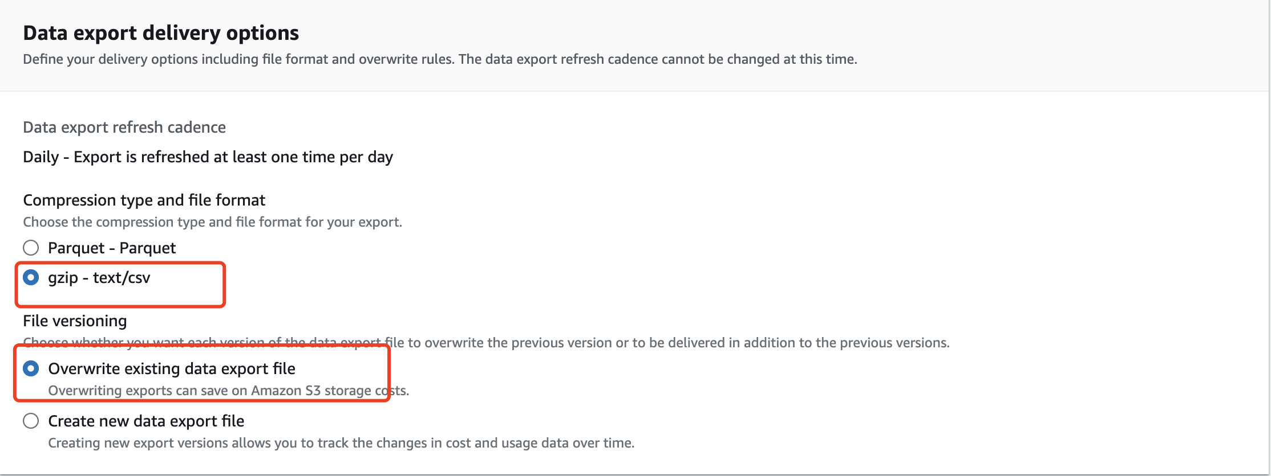
- Step5- Data export storage settings configuration:
  - S3 Bucket: Choose the target S3 bucket
  - S3 path prefix: Input the target prefix that you want to save the report.
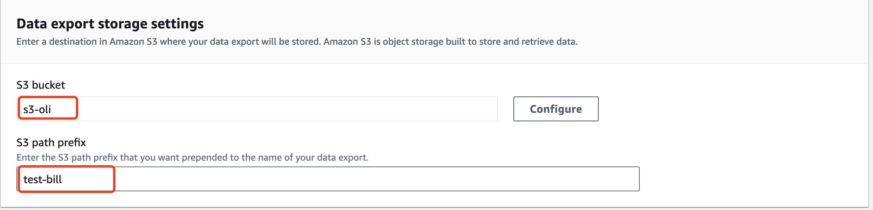
- Step6-Complete the report creation. It will wait a couple of minutes , and confirm the export name is Healthy.
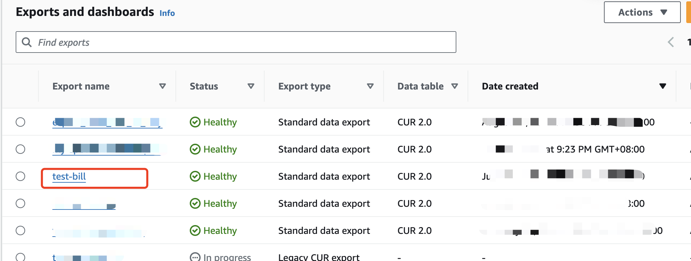
- Step7-After customer has done the above work, then go to the AWS Support Center, and create a Active case:
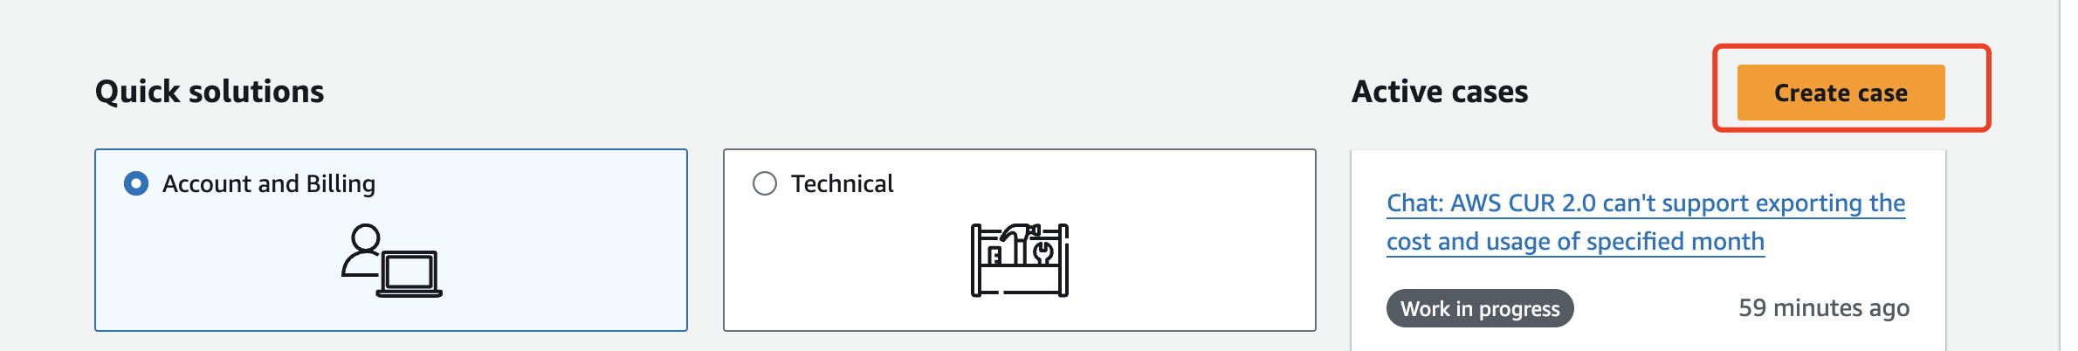
- Step8-Customer can choose the related issue for the case, and choose the Live Chat as discussion group.
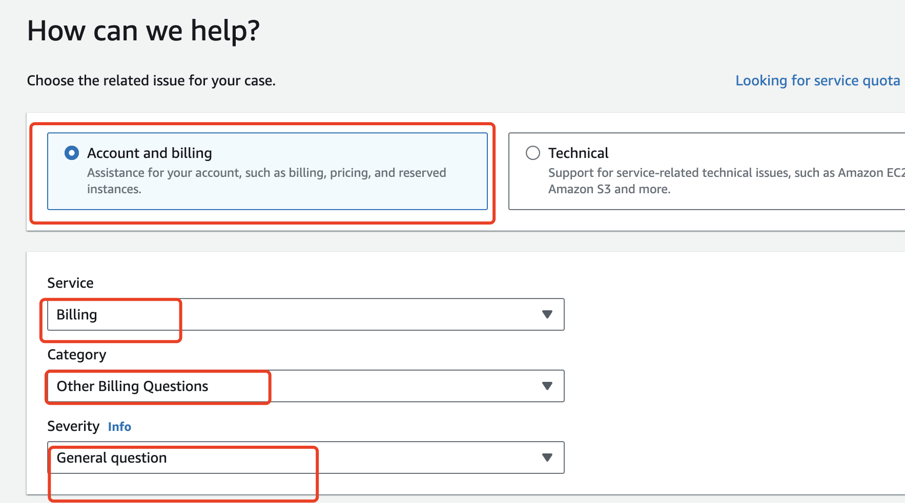
- Step9- Ask the AWS Service team to help to export the billing report of specifed month. Customer need provide the relevant information to AWS Service Team:
  - The Export Name: Refer to Step-2test-bill
  - The month : The month of billing report customer wanna export.
  - The S3 bucket name: The report will be exported to S3 bucket, customer need provide the S3 bucket for AWS Service Team to export.
  - The report file format: We recommend the CSV format.
- Step10- It will take some time for AWS Service Team to export,may be 24 hours.

